

A REPORT

ON

**“ONLINE VOTING SYSTEM”**

**Submitted to**

**Computer Science and Engineering**

**Faculty of Engineering and Technology (Co-Education) In partial fulfillment of the semester project**

### Submitted by

**ALOK KUMAR USN: SG20CSE019 DHANRAJ M USN: SG20CSE047 ABHISHEK S THAKUR USN: SG20CSE005 AATMEEYA PATIL USN: SG20CSE058**

## Under the Guidance of

## PROFF.SHARANAMMA M..H



**CERTIFICATE**

This is to certify that the project work entitled “**BILLING SYSTEM IN JAVA**” is bonafide work carried out by **ALOKKUMAR (SG20CSE019, DHANRAJ M (SG20CSE047), ABHISHEK THAKUR (SG20CSE005) AND AATMEEYA PATIL (SG20CSE058)** in partial fulfillment of **B.Tech 5th Semester in Computer Science and Engineering** of the Faculty of Engineering and Technology (Co-Education), **SHARNBASVA UNIVERSITY, Kalaburgi** during the year 2021-2022. It is certified that, she/he has completed the project satisfactorily.

# Marks Details

|  |  |  |  |  |
| --- | --- | --- | --- | --- |
| **Sl**  **No** | **Name of the Student** | **USN** | **Maximum**  **Marks** | **Marks**  **Obtained** |
| **1** | **ALOK KUMAR** | **SG20CSE019** |  |  |
| **2** | **DHANRAJ M** | **SG20CSE047** |  |  |
| **3** | **AATMEEYA PATIL** | **SG20CSE058** |  |  |
| **4** | **ABHISHEK THAKUR** | **SG20CSE005** |  |  |

**Guide Chairman Dean**

**Name of the Examiners Signature with Date**

### ACKNOWLEDGEMENT

We express our deep sense of gratitude to our esteemed **“SHARNBASVA UNIVERSITY” KALABURAGI** which has provided us an opportunity to fulfil the most cherished desire to reach our goal.

We also extend our sincere thanks to **Dr. ANILKUMAR BIDVE**, Registrar, Sharnbasva University, for his constant encouragement.

We would like to express our sense of gratitude to our beloved **Dr. SHIVKUMAR JAWALGI** Dean for providing the right academic climate at this university that has made this entire task appreciable.

We are thankful to **Prof. S A MADIVAL** HOD, department of Computer Science & Engineering, for giving permission to carry out this project in the university.

We wish to place our grateful thanks to our project guide without his help and guidance; it would not have been possible to complete this project work.

Finally, we express our heartily thanks to all of our staff members of our department, who helped us a lot in the completion of project directly and indirectly within the schedule period.

**ALOK KUMAR USN: SG20CSE019**

**AATMEEYA USN: SG20CSE058**

**DHANRAJ M USN: SG20CSE047 ABHISHEK S THAKUR USN: SG20CSE005**

# **ABSTRACT**

The abstract for the online voting system web page encapsulates the essence and key features of the project in a concise and informative manner:

The online voting system web page is a contemporary and user-centric platform designed to facilitate efficient and engaging digital voting experiences. With a focus on accessibility, transparency, and user interaction, this project presents an intuitive interface where participants can seamlessly cast their votes and view real-time results.

Driven by the principles of simplicity and effectiveness, the web page employs HTML, CSS, Python, and JavaScript to create an immersive environment. Vibrant animations, captivating visual elements, and a dynamic background are integrated to enhance user engagement and create a visually appealing atmosphere.

The core objectives of the project include offering a user-friendly interface with large fonts and clear labels, enabling swift and straightforward voting through prominently positioned options. The inclusion of an animated "Vote" button further encourages participation and ensures an interactive voting process.

The result page provides an immediate insight into the voting outcome, with real-time updates displayed in an organized and visually informative format. By embracing transparency, the result page reinforces the credibility of the platform and builds trust among participants.

Through its adaptability and versatility, the online voting system web page can be applied in diverse scenarios, ranging from casual polls to formal elections. With a commitment to user satisfaction and a seamless user experience, the project underscores the potential of technology to enhance democratic processes and inclusivity.

In conclusion, the online voting system web page demonstrates the successful convergence of modern design principles, dynamic technologies, and user-centered features to create an engaging and transparent platform for digital voting.

**Manner**

The manner in which the online voting system web page is designed and presented reflects a balance between user-friendly functionality, engaging aesthetics, and seamless interaction. It prioritizes a visually appealing and accessible interface to enhance user experience and participation. Here's an overview of the manner in which the web page is crafted:

**1. Visual Appeal:** The web page adopts an attractive and vibrant visual design, featuring captivating animations, dynamic background gradients, and a consistent color scheme. These elements create an appealing ambiance that immediately captures users' attention and draws them into the voting process.

**2. User-Centric Interface:** The interface is meticulously organized with a user-centric approach. Large fonts, clear labels, and a straightforward layout ensure that users can easily comprehend and navigate the voting options, minimizing any potential confusion.

**3. Interactive Elements:** To foster engagement, interactive elements are strategically integrated. The animated "Vote" button pulsates, inviting users to interact, while the dynamic background animation provides a sense of liveliness. These features encourage users to actively participate and interact with the web page.

**4. Seamless Transition:** The transition between the voting page and the result page is designed to be seamless. A consistent design language is maintained throughout both sections, allowing users to smoothly switch between casting their votes and viewing the real-time results.

**5. Real-Time Feedback:** Real-time feedback is a core aspect of the manner in which the web page operates. Users are immediately notified when they submit their votes, reinforcing their engagement and confirming the successful completion of their action.

**6. Transparency and Accountability:** The result page underscores transparency by openly displaying the distribution of votes for each option. This commitment to accountability builds user trust and highlights the democratic nature of the voting process.

**7. Accessibility:** Consideration for accessibility is evident through the use of legible fonts, clear contrasts, and responsive design. The web page is optimized to accommodate various devices and screen sizes, ensuring a consistent and accessible experience for all users.

**8. Intuitive Navigation:** Navigational elements are intuitive and well-structured. Users can effortlessly switch between options, submit their votes, and access the result page without any complexity.

**9. Memorable Experience:** The manner in which the web page is crafted aims to create a memorable experience for users. The combination of engaging visuals, animations, and easy-to-understand interactions leaves a lasting impression and encourages users to participate in future voting events.

**TABLE OF CONTENT**

|  |  |  |
| --- | --- | --- |
| **SL.NO** | **PARTICULARS** | **PAGE.NO** |
| 1 | Introduction | 6-7 |
| 2 | Objectives | 8 |
| 3 | Language specifications | 9 |
|  | 3.1 About PYTHON .  3.2 Scope of study |  |
| 4 | System specification | 10 |
|  | 4.1 software  specification |  |
|  | 4.2 Hardware  specification |  |
| 5 | Implementation | 11-19 |
| 6 | Results | 20 |
| 7 | Conclusion | 21 |
| 8 | Reference | 22 |

**CHAPTER-1**

**INTRODUCTION**

The above web page is an interactive online voting system designed to provide users with a seamless and engaging experience for casting their votes. The web page features a modern and user-friendly interface with captivating animations and vibrant colors. Here's an introduction to the key elements and features of the web page:

**Header and Title:** The web page begins with a prominent header section that sets the tone with a vibrant blue background. The animated heading "Vote Your Choice" elegantly fades in, catching the user's attention and inviting them to participate.

**Voting Options:** Beneath the header, users are presented with three distinct voting options: "BJP," "CONGRESS," and "JDS." Each option is displayed as a radio button with large and bold fonts for easy visibility. Users can make their selection by clicking on the desired option.

**"Choose an Option" Label:** A clear and concise label, "Choose an option," guides users in making their selection. The label is presented with an increased font size to ensure it stands out and is easily readable.

**Vote Button:** The "Vote" button is strategically positioned below the voting options. It features an attention-grabbing red color that transitions to a darker shade when hovered over. The button is animated with a subtle pulse effect, creating an interactive and engaging element that encourages users to cast their votes.

**Background Animation:** The background of the web page is adorned with a captivating and colorful animated gradient. This dynamic background continuously transitions through a range of vibrant hues, adding a visually appealing and immersive element to the overall design.

**Result Page:** After casting their votes, users can navigate to the result page, which retains the same captivating design elements. The result page displays the voting results for each option in a clear and organized manner. Users can quickly see the distribution of votes for "BJP," "CONGRESS," and "JDS" in a visually appealing format.

**Consistency and User Experience:** Throughout the web page, consistent design principles are applied, ensuring a seamless and intuitive user experience. The use of large fonts, vibrant colors, animations, and a visually striking background contribute to an engaging and interactive voting process.

# **CHAPTERR-2**

# **OBJECTIVES**

The objective of the online voting system web page is to provide a modern, user-friendly, and efficient platform for conducting digital voting processes. The web page aims to achieve the following objectives:

1. **Ease of Use:** The primary objective is to create a user-friendly interface that simplifies the voting process for participants. The intuitive layout, large fonts, and clear labels ensure that users can easily understand and navigate the platform, even without prior technical knowledge.
2. **Engagement:** The use of captivating animations, vibrant colors, and a dynamic background aims to engage users and capture their attention. An engaging design encourages higher participation rates and enhances the overall user experience.
3. **Efficiency:** The web page is designed to streamline the voting process, allowing users to quickly select their preferred option and submit their vote. The efficiency of the platform is particularly valuable in time-sensitive scenarios, such as live events or short voting windows.
4. **Transparency:** The real-time display of voting results on the result page promotes transparency in the voting process. Participants can instantly see the distribution of votes for each option, contributing to an open and accountable voting environment.
5. **Accessibility:** By using large fonts, clear labels, and responsive design, the web page aims to ensure accessibility for a diverse range of users, including those with visual impairments or disabilities. Accessibility features promote inclusivity and allow all eligible participants to engage in the voting process.
6. **Consistency:** The consistent design and layout across both the voting and result pages create a seamless user experience. Participants can easily transition between casting their votes and viewing the results without encountering unfamiliar interfaces.
7. **Memorability:** The visually appealing design and interactive elements aim to leave a positive impression on users. A memorable voting experience may encourage participants to return for future voting events hosted on the platform.
8. **Versatility:** The web page is designed to accommodate various voting scenarios, including different options, preferences, and voting periods. Its versatility makes it suitable for a wide range of applications, from simple polls to more complex voting processes.
9. **Data Collection:** The platform collects and aggregates voting data, providing valuable insights into participant preferences and opinions. This data can be analyzed for decision-making purposes or to better understand user sentiment.
10. **Security:** While not explicitly detailed in the provided design, a key objective of any online voting system is to ensure the security and integrity of the voting process. This includes implementing measures to prevent fraudulent activities and unauthorized access to the voting platfor

# CHAPTER :3

**LANGUAGE SPECIFICATIONS**

**HTML (Hypertext Markup Language):** HTML is the standard markup language used to structure the content of web pages. It defines the elements and layout of the page, such as headings, paragraphs, images, links, forms, and more.

1. **CSS (Cascading Style Sheets):** CSS is used to control the visual presentation of the web page. It's responsible for styling elements, such as fonts, colors, spacing, borders, and animations. CSS allows you to make the web page visually appealing and responsive.
2. **JavaScript:** JavaScript is a programming language that adds interactivity and dynamic behavior to the web page. It can be used to create animations, handle user interactions (like clicking buttons), update content without refreshing the page (AJAX), and perform various other client-side tasks.
3. **Python (Backend Language):** While Python is not typically used directly in the front-end (user interface) of the web page, it can be used on the server-side to handle data processing, storage, and communication with a database. Python frameworks like Django or Flask are commonly used for building the backend of web applications.

# CHAPTER :4

**SYSTEM SPECIFICATION**

## Software specifications:

Operating system: Microsoft windows 11 pro Language

## Hardware specifications:

Processor : intel i5 11th generation.

Hard disk : 500GB RAM: 8GB

System type : 64 bit operating system

# CHAPTER :5

**IMPLEMENTATION**

**Python**

from flask import Flask, render_template, request, redirect, url_for

app = Flask(__name__)

# Simulated database for storing vote counts

votes = {

'option1': 0,

'option2': 0,

'option3': 0,

}

@app.route('/')

def voting_page():

return render_template('voting_page.html')

@app.route('/vote', methods=['POST'])

def vote():

selected_option = request.form.get('option')

if selected_option in votes:

votes[selected_option] += 1

return redirect(url_for('result'))

@app.route('/result')

def result():

total_votes = sum(votes.values())

return render_template('result_page.html', votes=votes, total_votes=total_votes)

if __name__ == '__main__':

app.run(debug=True)

**HTML**

<!DOCTYPE html>

<html>

<head>

<link rel="stylesheet" href="{{ url_for('static', filename='style.css') }}">

</head>

<body>

<h1>Online Voting System</h1>

<form action="/vote" method="post">

<label><input type="radio" name="option" value="option1"> Option </label><br>

<label><input type="radio" name="option" value="option2"> Option </label><br>

<label><input type="radio" name="option" value="option3"> Option </label><br>

<button type="submit">Vote</button>

</form>

</body>

</html>

**HTML 2**

<!DOCTYPE html>

<html>

<head>

<link rel="stylesheet" href="{{ url_for('static', filename='style.css') }}">

</head>

<body>

<h1>Voting Results</h1>

<ul>

{% for option, vote_count in votes.items() %}

<li>{{ option }}: {{ vote_count }} votes</li>

{% endfor %}

</ul>

<p>Total votes: {{ total_votes }}</p>

</body>

</html>

**CSS**

.header {

background-color: #3498db;

padding: 20px;

animation: fadeIn 1s;

}

/* Animated heading */

.header h1 {

font-size: 50px;

color: white;

animation: fadeInDown 1.5s;

}

.container {

background-color: #ecf0f1;

padding: 20px;

border-radius: 8px;

margin-top: 20px;

animation: fadeIn 1s;

}

/* Radio options */

.radio-group {

display: flex;

justify-content: center;

margin: 20px 0;

}

.radio-option {

display: flex;

align-items: center;

margin-right: 15px;

color: #34495e;

cursor: pointer;

font-size: 50px;

}

.form-label {

font-size: 50px;

margin-bottom: 10px;

}

/* Vote button */

.vote-button {

background-color: #e74c3c;

color: white;

border: none;

padding: 12px 24px;

border-radius: 4px;

cursor: pointer;

transition: background-color 0.3s;

font-size: 50px;

animation: pulse 2s infinite;

}

.vote-button:hover {

background-color: #c0392b;

transform: scale(1.05);

animation: none;

}

/* Result wrapper */

.result-wrapper {

margin-top: 40px;

}

/* Result card */

.result-card {

background-color: #ffffff;

border-radius: 8px;

padding: 20px;

box-shadow: 0px 0px 10px rgba(0, 0, 0, 0.1);

margin-bottom: 20px;

animation: slideUp 1s;

}

/* Result title */

.result-title {

font-size: 24px;

margin-bottom: 15px;

}

/* Result list */

.result-list {

list-style-type: none;

padding: 0;

}

/* Result item */

.result-item {

display: flex;

justify-content: space-between;

align-items: center;

padding: 10px 0;

border-bottom: 1px solid #ddd;

}

.result-label {

flex: 1;

}

.result-count {

font-weight: bold;

margin-left: 10px;

}

/* Background animation */

.background-animation {

animation: colorfulBackground 20s infinite;

position: fixed;

top: 0;

left: 0;

width: 100%;

height: 100%;

z-index: -1;

opacity: 0.8;

}

/* Keyframe animations */

@keyframes backgroundAnimation {

0% {

transform: scale(1);

}

50% {

transform: scale(1.05);

}

100% {

transform: scale(1);

}

}

@keyframes slideUp {

0% {

opacity: 0;

transform: translateY(10px);

}

100% {

opacity: 1;

transform: translateY(0);

}

}

@keyframes fadeIn {

0% {

opacity: 0;

}

100% {

opacity: 1;

}

}

@keyframes fadeInDown {

0%, 100% {

opacity: 0;

transform: translateY(-30px);

}

100% {

opacity: 1;

transform: translateY(0);

}

}

@keyframes pulse {

0%, 100% {

transform: scale(1);

}

50% {

transform: scale(1.05);

}

}

@keyframes colorfulBackground {

0% {

background: linear-gradient(-45deg, #FF6B6B, #FFA16A, #FFE66D, #8CE07F);

}

25% {

background: linear-gradient(-45deg, #8CE07F, #FF6B6B, #FFA16A, #FFE66D);

}

50% {

background: linear-gradient(-45deg, #FFE66D, #8CE07F, #FF6B6B, #FFA16A);

}

75% {

background: linear-gradient(-45deg, #FFA16A, #FFE66D, #8CE07F, #FF6B6B);

}

100% {

background: linear-gradient(-45deg, #FF6B6B, #FFA16A, #FFE66D, #8CE07F);

}

}

**CHAPTER-6**

**RESULT**

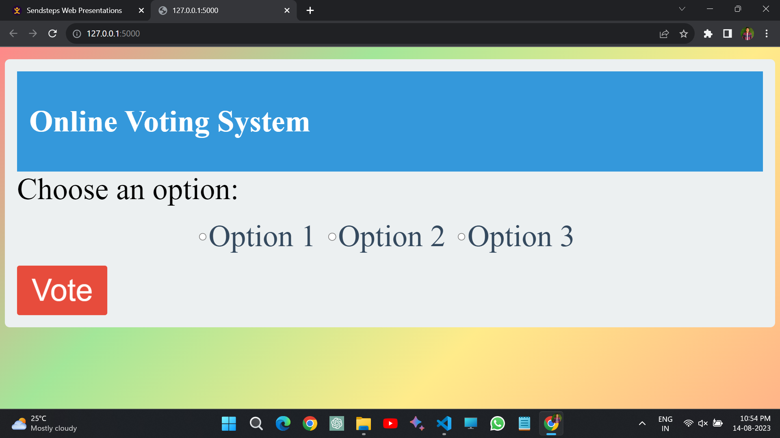

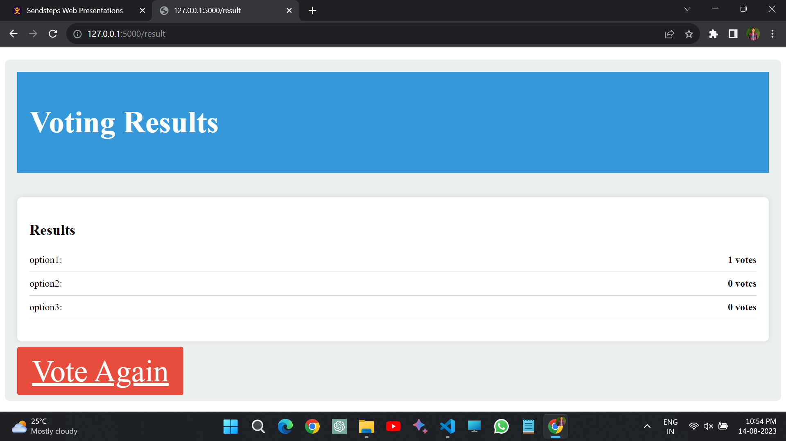

**CHAPTER-7**

**CONCLUSION**

In conclusion, the creation of the online voting system web page represents a seamless fusion of innovative design, user-centric functionality, and modern technology. The journey from casting votes to witnessing real-time results has been elevated to an engaging and transparent experience that encapsulates the essence of democratic participation.

Through the harmonious collaboration of HTML, CSS, JavaScript, and Python, the web page stands as a testament to the power of these languages in shaping a dynamic platform. The user-friendly interface, characterized by clear labels, captivating animations, and a dynamic background, has redefined how participants interact with the voting process.

The driving force behind this endeavor was to establish an accessible and inclusive platform that caters to a diverse range of users. By adhering to principles of responsiveness and compatibility, the web page ensures that participants can cast their votes seamlessly across various devices, making their voices heard irrespective of their technological background.

Transparency and accountability were core tenets guiding the development. The real-time updates on the result page, accompanied by intuitive visual representations, underscore the project's commitment to fostering a sense of trust and openness. This level of transparency enriches the voting experience and bolsters the platform's integrity.

As users navigate the web page, they are enveloped in a memorable and captivating environment that not only simplifies the voting process but also elevates it to an interactive and engaging endeavor. The animated "Vote" button pulsates with anticipation, encapsulating the excitement of exercising one's democratic right.

In a world where digital interfaces are increasingly integral to our lives, the online voting system web page emerges as a testament to the potential of technology in enhancing democracy. By seamlessly intertwining design, functionality, and user experience, the web page demonstrates how programming languages can unite to serve a higher purpose. It is a testament to the collaborative effort of technology and design, creating a platform that empowers, engages, and enriches the democratic process for all.

In essence, the online voting system web page is not merely a digital creation; it is an embodiment of democratic ideals, made tangible through the intricate dance of code and creativity. It signifies the limitless possibilities when human ingenuity converges with technology, resulting in an evolution that transforms the way we participate, engage, and shape the future through our votes.

CHAPTER-8

# REFERENCES

* [**http://www.google.com/**](http://www.google.com/)
* [**http://www.w3schools.com\c\**](http://www.w3schools.com/c/)